Block 3

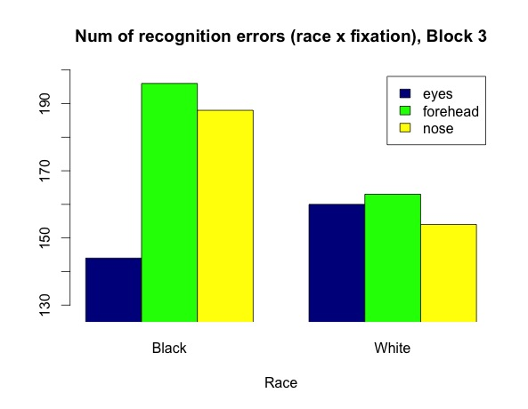

Fix x Race (Num of errors)

Black White

eyes 144 160

forehead 196 163

nose 188 154

Percentages (out of 432 trials)

Black White

eyes .33 .37

forehead .45 .38

nose .44 .36

> int <- aov(NumErr ~ (Fix*Race)+Error(Subnum/(Fix*Race)), data = wide)

> summary(int)

Error: Subnum

Df Sum Sq Mean Sq F value Pr(>F)

Residuals 26 553.8 21.3

Error: Subnum:Fix

Df Sum Sq Mean Sq F value Pr(>F)

Fix 2 29.37 14.685 4.159 0.0211 *

Residuals 52 183.63 3.531

Error: Subnum:Race

Df Sum Sq Mean Sq F value Pr(>F)

Race 1 16.06 16.056 3.319 0.08 .

Residuals 26 125.78 4.838

Error: Subnum:Fix:Race

Df Sum Sq Mean Sq F value Pr(>F)

Fix:Race 2 30.26 15.13 4.385 0.0174 *

Residuals 52 179.41 3.45

**One-way ANOVAs within Race**

Black faces:

Error: Within

Df Sum Sq Mean Sq F value Pr(>F)

Fix 2 21.4 10.710 1.901 0.157

Residuals 75 422.6 5.634

White faces:

Error: Within

Df Sum Sq Mean Sq F value Pr(>F)

Fix 2 0.4 0.192 0.024 0.976

Residuals 75 599.6 7.994

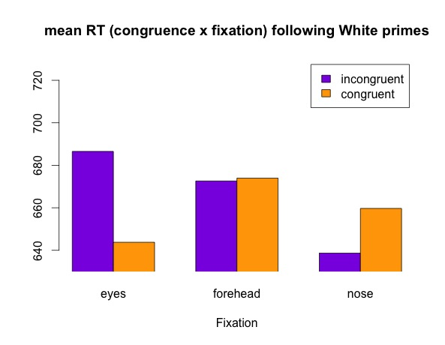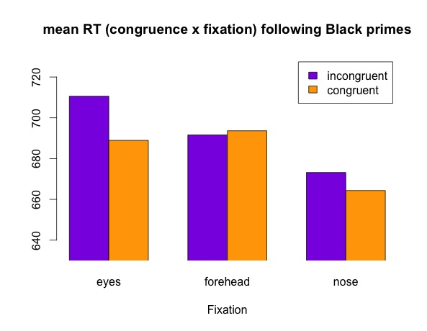Block 2

|  |  |  |  |  |  |
| --- | --- | --- | --- | --- | --- |
| Means | Black |  | White |  | Marg.means |
|  | Congruent | Incong | Congruent | Incong |  |
| Eyes | 690.4965 | 713.8535 | 648.2075 | 689.5907 | 685.5616 |
| Forehead | 698.3310 | 693.2158 | 678.4336 | 672.6227 | 685.6368 |
| Nose | 665.8492 | 679.2313 | 664.1562 | 643.0769 | 663.0722 |

> intlogRT <- aov(logRT ~ (Fix*Race*Congruent)+Error(Subnum/(Fix*Race*Congruent)), data = widelog)

Error: Subnum:Fix

Df Sum Sq Mean Sq F value Pr(>F)

Fix 2 0.01960 0.009802 5.259 0.00832 **

Residuals 52 0.09693 0.001864

Error: Subnum:Race

Df Sum Sq Mean Sq F value Pr(>F)

Race 1 0.02552 0.025522 11.8 0.002 **

Residuals 26 0.05623 0.002163

Error: Subnum:Fix:Race:Congruent

Df Sum Sq Mean Sq F value Pr(>F)

Fix:Race:Congruent 2 0.00533 0.002665 2.063 0.137

Residuals 52 0.06718 0.001292